**WEEK 13**

**Quiz 2**



**Name**

Sherly Lutfi Azkiah Sulistyawati

**NIM**

2341720241

**Class**

1I

**Major**

Information Technology

**Study Program**

D4 Informatics Engineering

Github link: <https://github.com/sherlyazkiah/AlgoritmadanStrukturData/tree/main/Practice/Week13>

1. addLast method is use for add a new node at the end of the list.

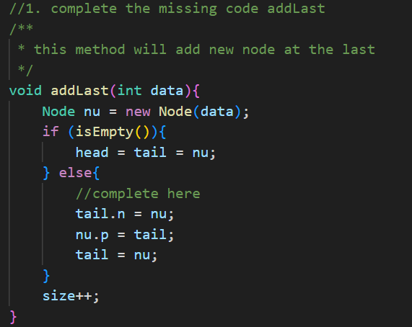

This is the example of addLast method. The new node will add after 45 and after 25.

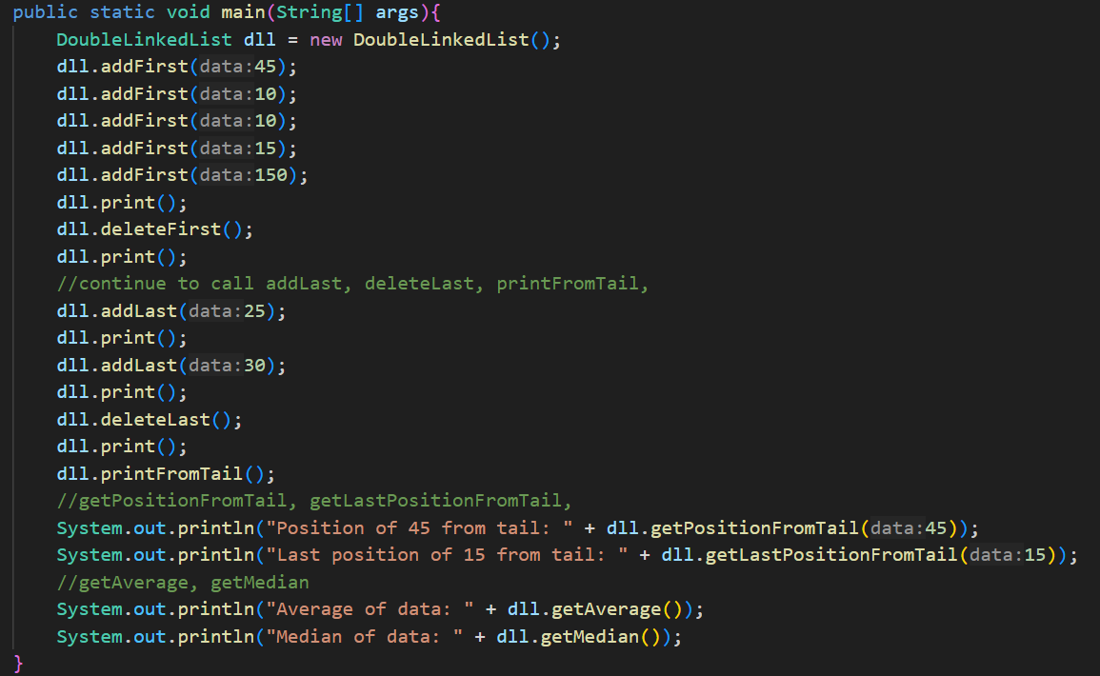

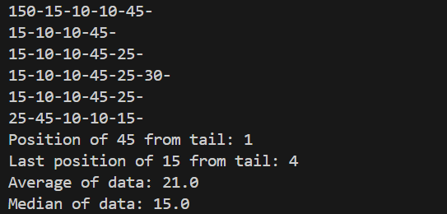

1. deleteLast method is use for remove the last node.

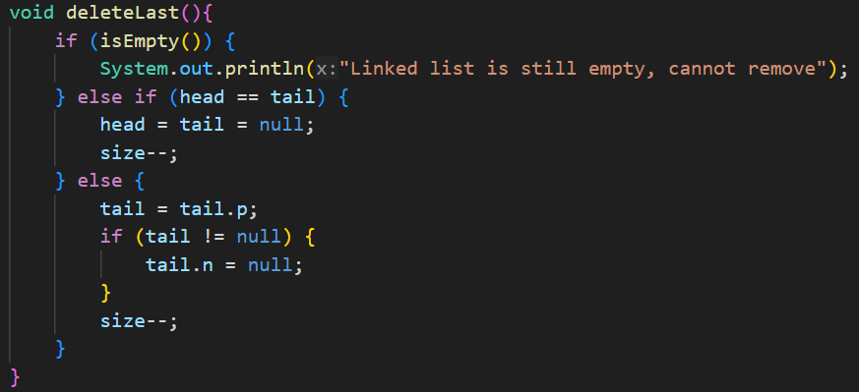

This is the example of deleteLast method. The last node (30) will remove from the list.





1. printFromTail method is use for traverses and prints all data from tail to head.

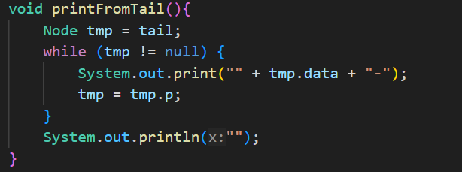

This is the example of printFromTail method. The data prints from the tail to head.





1. getPositionFromTail method is use for find positions relative to the tail.

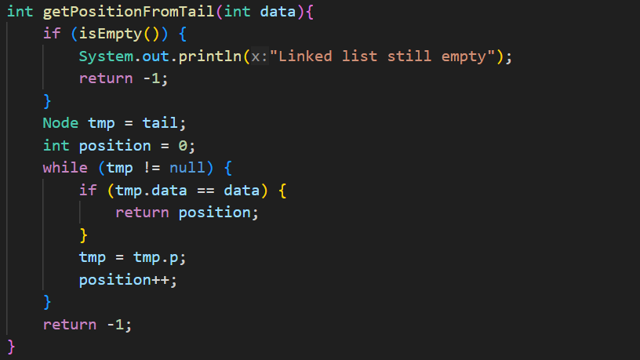

This is the example of getPositionFromTail method. thi s method will return the position of data from last







1. getLastPositionFromTail method is use for find the data and the searching start from last.

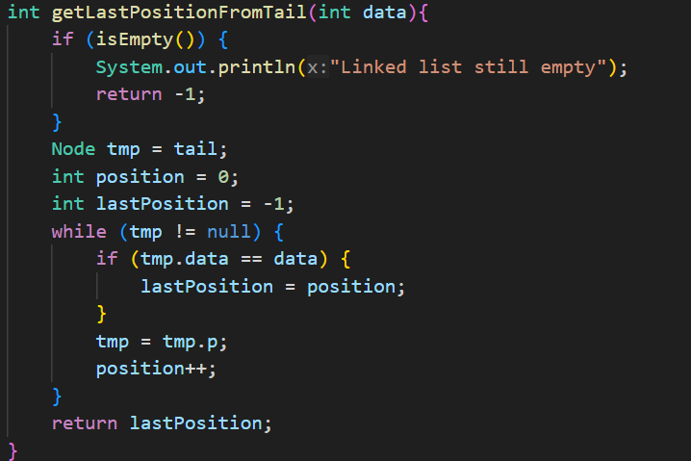

This is the example of getLastPositionFromTail method. This method will return the last position where the data found and the searching start from last.







1. getAverage method is use for calculates the average of all nodes' data.

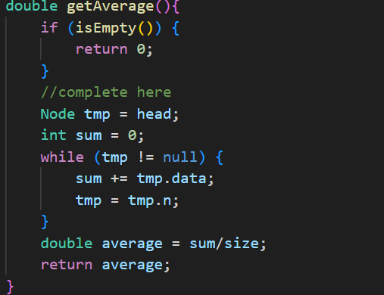

This is the example of getAverage method. It will calculate all the data and divide into the size of the list.







1. getNodeByIndex retrieves a node by its index.

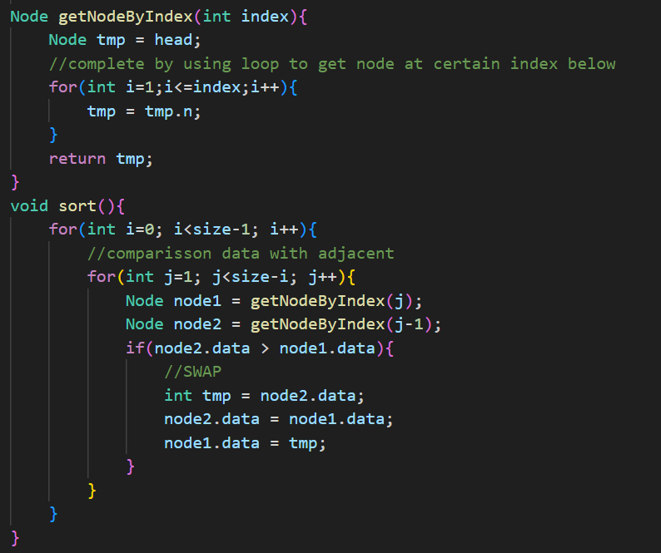







1. getMedian method is use for calculates the median value after sorting the list.

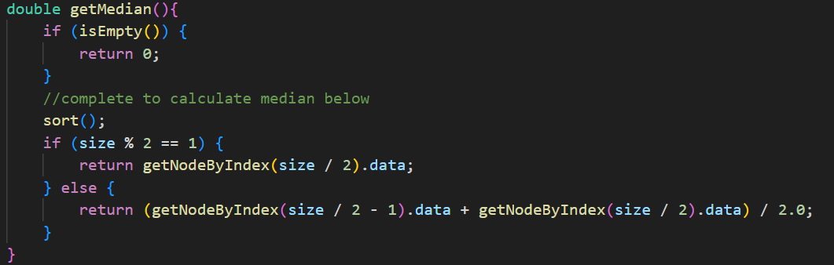

This is the example of getMedian methods.







1. Main class

